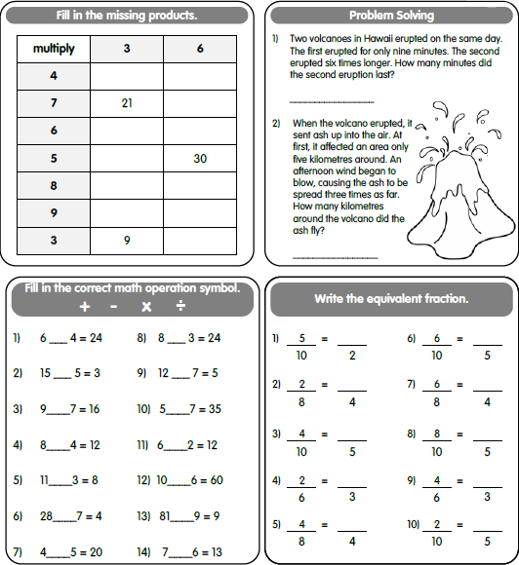

4F Week 1, Term 4 Homework

**Reading** – Complete your reading each night and fill in your reading sheet.

**Spelling** – Write one column of your spelling words each day.

**English** – We are learning about advertising this term. List 5 different ads you see this week. What is the message?